## CMPE 30213 On-The-Job Training 2 (300 hours) ON-THE-JOB TRAINING – EXPERIENCE LexMeet – Internship Accomplishments

**Name of Student: Katrina Ricci C. Batin Company Name: LexMeet Inc. Company Address: Unit 608 6th Floor AIC Burgundy Empire Tower, ADB Ave, Ortigas Center, Pasig, 1605 Metro Manila**

**OJT Adviser/s: Engr. Julian S. Lorico**

**First Discord meeting with sir BM Alpuerto for setting up VS code**

**LexMeet Interns Tasks**

**LexMeet Exercise Task: To-do App**

**WOCEE/WOSAS Exhibit (August 7, 2024)**

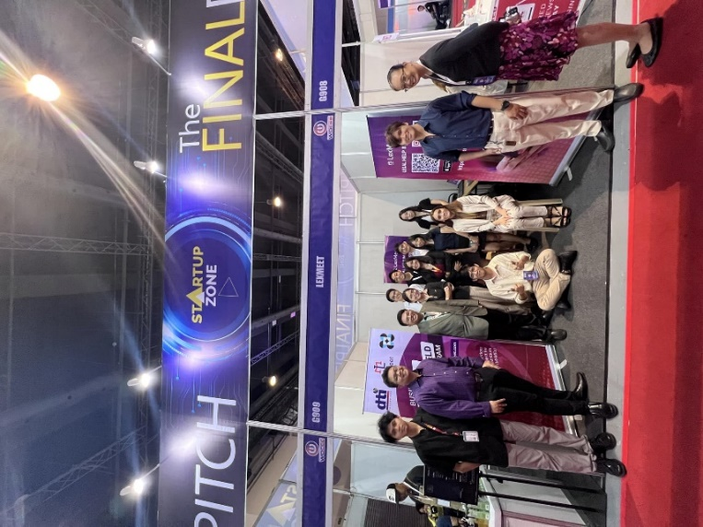

**1st Assigned Project: LexMeet CMS – Home Page**

**Intern’s Daily Accomplishment reports**

**CMS Meeting for progress checking and merging**

**2nd Assigned project: Contract Verifier – Lawyer Review 3: Type and Speak Story**

